Transportation Guide for International Visitors

Xi' an Jiaotong University, China (西安交通大学)
Address: No.28 Xianning West Road, Xi'an, Shaanxi 710049, P.R. China

Site / Arrival Information
Xi'an Xianyang International Airport (西安咸阳国际机场, XIY）
https://reurl.cc/NYYVzn

- Airport to Xi'an Jiaotong University Transportation Information:
From Xi'an Xianyang International Airport to Xi'an Jiaotong University, you have the following transportation options:
1. Airport Limousine Bus
- Route: Airport Limousine Bus "Xishaomen Line" (西稍门线)→ Metro Line 1 (Kaiyuanmen Station 开远门站) → Metro Line 3 (Xiaozhai Station小寨站) → Jiaotong University Station交通大学站
- Cost: Airport bus is about 25 yuan, subway fare is 3-5 yuan
- Total duration: about 1.5 hours
- Steps:
  - Take the limousine bus "Nishishaomen Line(西稍门线)" from Terminal T2 or T3 of the airport and arrive at the "Nishishaomen" station in about 50 minutes
  - Walk to Kaiyuanmen Subway Station 西稍门(about 5 minutes) and take Metro Line 1 to Beidajie Station北大街
  - Transfer to Metro Line 2 to Xiaozhai Station小寨
  - Then transfer to Metro Line 3 to Xi'an Jiaotong University Station 西安交通大学and walk into the campus

2. Subway routes: Airport Intercity Railway→ Metro Line 4 → Metro Line 3 (Jiaotong University Station交通大学站).
- Cost: about 15 yuan for the whole journey
- Total duration: about 1.5 hours
- Steps:
  - Take the Airport Intercity Railway from Terminal 3 to the "North Railway Station北客站" station
  - Transfer to Metro Line 4 to Big Wild Goose Pagoda Station 大雁塔
  - Then transfer to Metro Line 3 to Xi'an Jiaotong University Station 西安交通大学and walk into the campus

3. Taxi
- Cost: about 100-150 yuan
- Total duration: about 45-60 minutes
- When to use: If you have a lot of luggage or share the cost with friends, a taxi (a ride-hailing app in China) will be more convenient
- Recommended Route:
  - Navigate directly to "Xi'an Jiaotong University Xingqing Campus 西安交通大学兴庆校区" (University faculties and dormitories)
  - During peak periods, it is recommended to avoid the Third Ring Expressway, and you can take the Ring Expressway + Xianning West Road (咸宁西路) for a faster time

4. Airport Express
- Route: "Airport Express Line 2" directly to "Zhonglou"(钟楼) Station → Metro Line 2 → Metro Line 3 (Jiaotong University Station).
- Cost: about 16 yuan for the airport express line, about 3-5 yuan for the subway
- Total duration: about 1.5 hours
- When to go: If you arrive at the right frequency on the Airport Express, you can consider this option

Summary of Recommended Routes
If you have time, it is recommended to take the limousine bus or subway, and if you are in a hurry or have large luggage, you can take a taxi.
manner | expenses | Duration | Suitable for
Airport Limousine + Metro | About 30 yuan | Approximately 1.5 hours | Affordable with less luggage
Airport Intercity Railway + Metro | About $15 | Approximately 1.5 hours | Cheap and suitable for traveling light
taxi | About 100-150 yuan | About 45-60 minutes | Convenient, luggage more or more people traveling
Airport Express + Metro | About $20 | Approximately 1.5 hours | If the frequency is suitable, it is more convenient

- Hotel Information:
- Xi'an Jiaotong University Nanyang Hotel (西安交大南洋大酒店)
- http://nanyang.hotels-xian.com/
- Address: No. 1, Xingqing South Road, Xi'an, Beilin District, Xi'an, Shaanxi Province, China
- Double room and standard room, 460 yuan per room, including double breakfast, the agreed price on campus.
Destination: Nanyang Hotel
1. Airport Shuttle Bus (available at Terminals T2, T3, or T5)
Arrival between 8:00 AM – 9:00 PM
- Route 1: Take the airport shuttle bus "Zhonglou West Line" → Get off at Andingmen Station / Zhonglou Station → Walk to Metro Line 6 Zhonglou Station → Exit at Jiaotong University · Xingqinggong Station Exit B → Walk about 15 minutes or take a 5-minute taxi ride to Nanyang Hotel.
- Route 2: Take the airport shuttle bus "Zhonglou North Line" → Get off at Zhonglou Station → Walk to Metro Line 6 Zhonglou Station → Exit at Jiaotong University · Xingqinggong Station Exit B → Walk about 15 minutes or take a 5-minute taxi ride to Nanyang Hotel.
- Route 3: Take the airport shuttle bus "West High-Tech Business Express Line" → Get off at Xiyaotou Station → Walk to Metro Line 5 Xiyaotou Station → Exit at Yanxiang Road North Exit A → Walk about 10 minutes to Nanyang Hotel.
Cost: Airport shuttle bus 25 RMB, Metro ticket 3-5 RMB
Total Duration: About 1 hour 30 minutes
Arrival between 10:00 PM – 1:00 AM (Last metro trains for Lines 5 and 6 are at 11:00 PM)
- Route: Take the airport shuttle bus "Night Line 1/2" → Get off at Zhonglou Station → Take a taxi (about 20 minutes) to Nanyang Hotel.
Cost: Airport shuttle bus about 25 RMB, taxi about 15 RMB
Total Duration: About 1 hour

2. Metro Route
- Take Metro Line 14 from Airport West Station (T1/T2/T3 terminals) → Get off at Xi'an North Station → Transfer inside the station to Metro Line 4 → Get off at Xi'an University of Architecture and Technology · Lijiacun Station → Transfer to Metro Line 5 → Exit at Yanxiang Road North Exit A → Walk about 10 minutes to Nanyang Hotel.
Cost: About 15 RMB
Total Duration: About 1 hour 40 minutes

----------------------------------------------------
- Xi'an Dequan Hotel(西安德泉酒店)
- https://www.hotelincn.com/49931/
- Address:Shaanxi Province, China · Xi'an · Beilin District · 159 Xingqing Road
- Double bed room (including single breakfast), 350 yuan per room; Standard room (including double breakfast), 350 yuan per room, the agreed price in the school
Destination: Dequan Hotel
1. Airport Shuttle Bus (available at Terminals T2, T3, or T5)
Arrival between 8:00 AM – 9:00 PM
- Route 1: Take the airport shuttle bus "Zhonglou West Line" → Get off at Andingmen Station / Zhonglou Station → Walk to Metro Line 6 Zhonglou Station → Exit at Jiaotong University · Xingqinggong Station Exit F → Walk about 8 minutes to Xi'an Dequan Hotel.
- Route 2: Take the airport shuttle bus "Zhonglou North Line" → Get off at Zhonglou Station → Walk to Metro Line 6 → Exit at Jiaotong University · Xingqinggong Station Exit F → Walk about 8 minutes to Xi'an Dequan Hotel.
Cost: Airport shuttle bus about 25 RMB, Metro ticket 3 RMB
Total Duration: About 1 hour 30 minutes
Arrival between 10:00 PM – 1:00 AM (Last metro trains for Lines 5 and 6 are at 11:00 PM)
- Route: Take the airport shuttle bus "Night Line 1/2" → Get off at Zhonglou Station → Take a taxi (about 20 minutes) to Dequan Hotel.
Cost: Airport shuttle bus about 25 RMB, taxi about 15 RMB
Total Duration: About 1 hour

2. Metro Route
- Take Metro Line 14 from Airport West Station (T1/T2/T3 terminals) → Get off at Xi'an North Station → Transfer inside the station to Metro Line 4 → Get off at Dacha City Station → Transfer to Metro Line 6 → Exit at Jiaotong University · Xingqinggong Station Exit F → Walk about 8 minutes to Xi'an Dequan Hotel.
Cost: About 15 RMB
Total Duration: About 1 hour 30 minutes

Besides the above public transportation options, you can also take a taxi from Xi'an Xianyang International Airport to the hotels. Please go to the designated taxi boarding points:
- Taxi
- Didi App (Ride-hailing service)
Cost: About 150–180 RMB
Total Duration: About 50 minutes
Recommended Situation:
If you have a lot of luggage or are traveling with friends to split the fare, a taxi (or ride-hailing app) will be more convenient.
Note: According to Xianyang Airport regulations, only licensed drivers from the Didi platform are allowed to provide ride-hailing services. If the platform matches you with an unlicensed driver, you can cancel the order and request another ride. Once inside Xi'an city, there are more ride-hailing platform options available: WeChat, Amap (Gaode Map), Baidu Map, Didi, Tencent Map, etc.

Destination: Xi'an Jiaotong University Campus (South Gate, North Gate, Southeast Gate — the School of Management is near the South Gate)
- From Nanyang Hotel to Xi'an Jiaotong University: 4-minute walk to the South Gate; 4-minute walk to the Southeast Gate; 18-minute walk to the North Gate.
- From Dequan Hotel to Xi'an Jiaotong University: 16-minute walk to the South Gate; 6-minute walk to the Southeast Gate; 8-minute walk to the North Gate.
- From Dequan Hotel to Nanyang Hotel: 12-minute walk to Nanyang Hotel.

- Xi'an attractions recommended

Recommended attractions around Xi'an Jiaotong University (Xingqing Campus):
- Xingqinggong Park (兴庆宫公园) https://www.xingqinggong.com/: It is located at No. 55, Xianning West Road, Beilin District, Xi'an City, close to Xi'an Jiaotong University. The park covers an area of 780 acres and the lake covers an area of about 150 acres, which is a paradise in the city. Every spring, tulips, peonies and other flowers bloom in the park, attracting a large number of tourists. Admission to the park is free and no reservation is required.
- Xi'an City Wall (西安城墙) http://www.chinaxiancitywall.com/index.php?m=pc: The Xi'an Ancient City Wall is one of the largest and best-preserved ancient city walls in China, surrounding the urban area of Xi'an and with a total length of about 13.7 kilometers. You can ride or stroll around the city walls and feel the history of the ancient city.
- Bell Tower and Drum Tower: (钟楼与鼓楼)Located in the center of Xi'an, the Bell Tower and Drum Tower were important buildings in the Ming and Qing dynasties, symbolizing the history and culture of the ancient city. At night, the bell and drum towers are even more magnificent under the illumination.
- Shuyuanmen Pedestrian Street: (书院门步行街) Known for selling paintings, calligraphy, antiques and handicrafts, this quaint street is a great place to experience Xi'an's traditional culture. The Ming and Qing architectural style shops on both sides of the pedestrian street show the rich cultural heritage.
- Shaanxi History Museum(陕西历史博物馆) https://www.sxhm.com/: As one of the famous history museums in China, the museum has a large collection of precious cultural relics, showing the rich historical and cultural heritage of Shaanxi. It is recommended to make an appointment in advance.

Xi'an Attractions/Food The attractions are all located near Xi'an Jiaotong University and are suitable for arranging a tour itinerary.
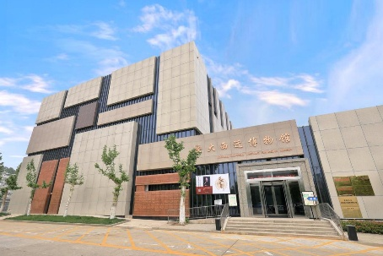 | Jiaotong University Westward Migration Museum  Xi'an Jiaotong University (Xingqing Campus)  - Show the process of Xi'an Jiaotong University moving from Shanghai to Xi'an  - Covers topics such as school history, education, engineering technology, etc., with a strong academic atmosphere
 | Cherry Blossom Avenue (East Cherry Blossom Avenue, West Cherry Blossom Avenue)  - On the campus of Xi'an Jiaotong University, cherry blossoms bloom every spring, forming a spectacular sea of ​​flowers. It is one of the most popular flower-viewing spots on campus.
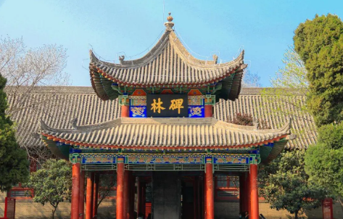 | Forest of Steles Museum  - A collection of numerous inscriptions and epitaphs from past dynasties, a paradise for calligraphy lovers  - Gain a deeper understanding of the development of Chinese calligraphy, literature and history
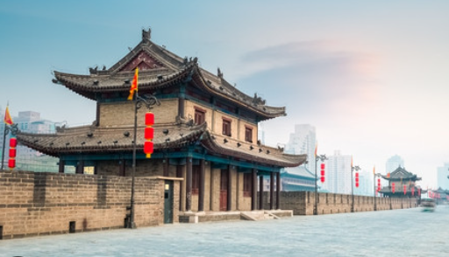 | Xi'an Ancient City Wall  - A Ming Dynasty relic, well preserved, you can walk or ride a bicycle around the city  - Climb the city in the evening to enjoy the sunset. The night view and light show are very spectacular.
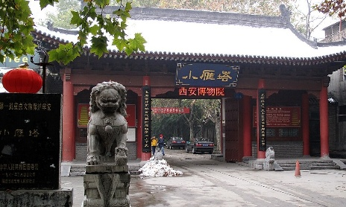 | Small Wild Goose Pagoda and Xi'an Museum  - The Small Wild Goose Pagoda is a Tang Dynasty Buddhist pagoda, and the Xi'an Museum houses a large number of cultural relics from the Xi'an area.  - The scenic area also has a quiet garden design, integrating history and nature
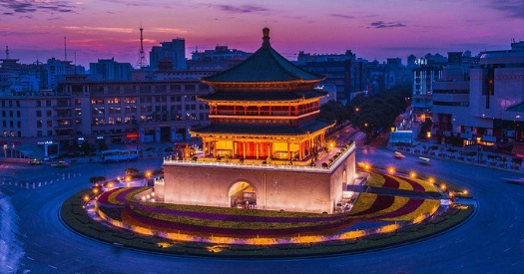 | Xi'an Bell Tower  - The Beilin District of Xi'an is located at the geometric center of the ancient city of Xi'an. It is one of the most representative buildings in Xi'an and a core landmark of transportation and culture.  - The ancient "morning bell and evening drum" system originated from here, which echoes the drum tower in the west and is part of the ancient city time management system
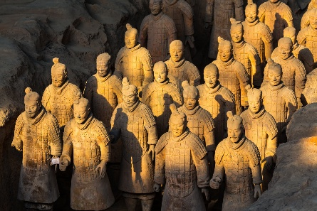 | Qin Shi Huang Terracotta Warriors and Horses Museum  - The Terracotta Warriors and Horses of Qin Shi Huang are the mausoleum of Qin Shi Huang, the emperor of the Qin Dynasty in China. It is also the first imperial mausoleum in China that is large in scale, elaborate in layout and well-preserved.
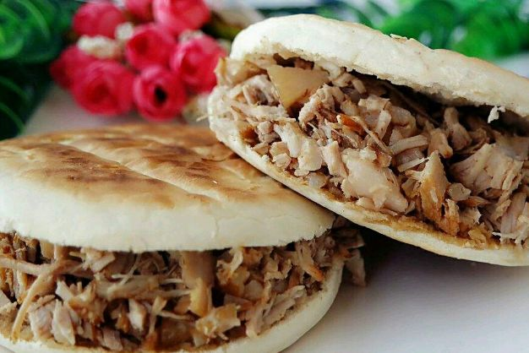 | 「Ancient City Food」Xi'an is one of China's food capitals  Roujiamo is known as the "hamburger" of China, but compared to the hamburger, it is healthier and more Chinese in flavor. The crust is crispy and browned, the meat is flavorful and fresh, very delicious, refreshing and not greasy.
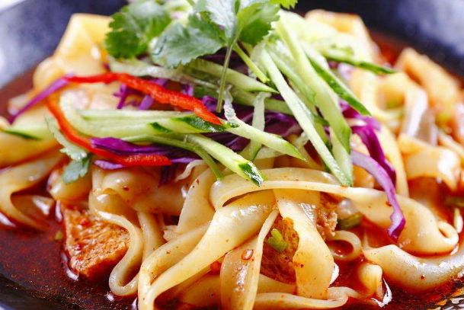 | Liangpi is one of the special snacks in Xi'an. It is very simple to make. Just put the seasonings and vegetables in the cold skin and mix them. It tastes very fragrant.
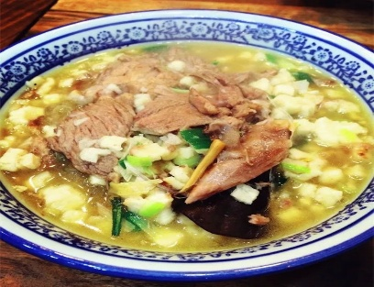 | Mutton soup with steamed bun is undoubtedly one of the most representative delicacies in Xi'an. The meat is tender and tasty, and the steamed bun tastes fresh and fragrant. You will have an endless aftertaste after eating it.
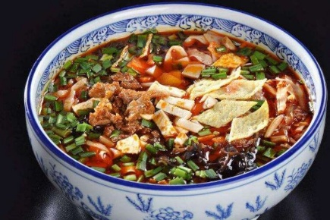 | Saozi noodles are one of the most famous noodles in the whole Shaanxi Province, and are also a delicacy with a more Han flavor. Its noodles are chewy and smooth, and taste fresh, spicy and sour.

